25th March 2026

Dear Parents,

Information about Camden Classics: a free after-school club devoted to the study of Latin and Roman Civilisation for pupils in Camden in Year 8.

My name is Rosie Turnor, a teacher of Classics at South Hampstead High School. I am writing to let you know about an after-school club in which young people in the Camden area with an interest in the ancient world can study Latin and Roman Civilisation. No previous knowledge of Latin is expected. In their first year (Year 8) participants follow the Suburani course which not only helps students develop a strong understanding of linguistic structures, but also fosters a deep appreciation of Roman culture and civilisation. The course is engaging, accessible, and encourages curiosity about the ancient world. Those who wish to continue then work towards the WJEC Level 1 Certificate in the second and third year (Years 9 and 10). This is a nationally recognised qualification which will be a valuable addition to your child’s academic achievements. It serves as an excellent stepping stone to further study in classical subjects. The exam will fall at the end of year 10, and therefore not clash with the rest of pupils’ GCSEs.

Camden Classics launches in September 2026, following on from South Hampstead High School’s outreach programme with UCL Academy, where we have had 20 participants over 3 years. Three Year 10 pupils sat the WJEC Level 1 Certificate last year, with two earning fantastic A*s and one a C, and a second cohort of six participants is sitting the exam this summer.

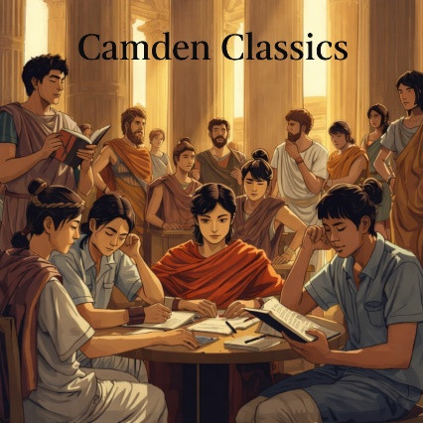
At present, Latin is only offered to young people attending Camden’s independent schools and Camden High School for Girls, Maria Fidelis Catholic School FCJ, and to Year 7 at La Sainte Union Catholic School. The Classics department at South Hampstead High School is launching Camden Classics in order to give every young person in our community a chance to study and enjoy Classics.

The beauty and intellectual challenge of Latin and Roman civilisation provide strong motivation to take part. The subject is highly regarded on university applications, and students also have the chance to meet others with similar interests from different schools. Classes are lively and enjoyable, and while language learning is our core focus, we spend plenty of time investigating Roman life and culture.

Participants will attend one hour-long session per week, at 4.30-5.30pm on Tuesdays during term time (with a first meeting on Tuesday 8th September) – though the sign-up form asks about other slots on Wednesday afternoons. The first three sessions will be taster sessions; after that, a high level of commitment will be expected: participants will need to attend the club and to undertake about 30 minutes’ worth of homework every week in Year 9 and Year 10. Teaching takes place in a classroom at South Hampstead High School, meaning we will be in easy reach of the school’s excellent collections of classical books.

Participation in the club is free of charge. Participants will be lent copies of the Suburani textbook (though they are welcome to buy their own) and will be supplied with all course materials.

If your child is interested in taking part, please fill in the expression of interest form below as soon as possible and no later than Friday 1st May 2026. This does not commit your child to the course.

Camden Classics- Expression of Interest Form.

I will be hosting a Q&A video call on Tuesday 28th April to provide an overview of the course and answer any questions. In addition, there will be an open session later on in the Summer Term, when you and your child will be warmly invited to visit South Hampstead to try out some Latin, experience what it is like to decode the language of the ancient world, and discover more about the lives, stories, and achievements of the Romans.

If you have any questions, please do email me at r.turnor@shhs.gdst.net

Yours sincerely,

Rosie Turnor

Teacher of Classics
South Hampstead High School

