East London Classics Summer School
9 Shepherd’s Lane, Homerton, London, E9 6JJ
www.eastlondonclassicssummerschool.com
Email eastlondoncss@gmail.com
X / Insta @ELCSS2
Facebook: Classics elcss
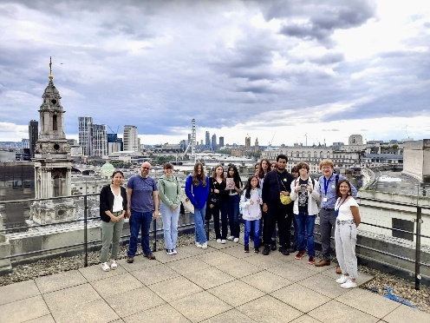

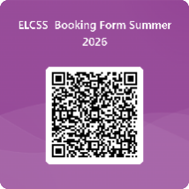
salve GCSE Latinist!

We are the East London Classics Summer School, and we put on language courses for students studying GCSE Latin in preparation for examinations. We are a team made up of experienced classics teachers of Latin, ancient Greek and Classical Civilisation. Six years ago, we set up the East London Classics Summer School to better serve budding classicists – like you – which aims to fully, and truly, champion equity and EDI.

It’s important to us, and our supporters, that we enable as many young people as possible to experience, and thrive, in subjects that celebrate the ancient world, its language, customs and culture - and we offer financial support to any student who requires it.

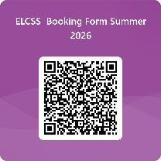
Therefore, we’d like to make you aware of these upcoming opportunities:

Yr10 Summer School 2026: sign-up via QR code →
- Mon 27 - Fri 31 July 2026 (five full days)
- Venue - modern & comfortable office space in Hackney, London
- £250 (including snacks)
- The Golden Lecture series is almost entirely GCSE exam set text centred
- Attendance at the summer school will guarantee you a place on our
highly popular Easter revision course in March 2027.

Yr11 GCSE Easter Latin Revision 2027
- Tues 30 - Wed 31 March 2027 (two full days)
- Venue - modern & comfortable office space in Hackney, London
- £150 (including snacks)
- Details will be announced at the start of the autumn term 2026, with priority given to students from our summer school.

Here are some comments from former ELCSS students who were in your position this time last year:
- The energy was amazing; it wasn't at all awkward. Our tutor had a unique and fun teaching style and did her absolute best to help us.
- The small group sizes allowed better communication.
- It simplified topics that seemed hard and made it look easy, like participles and pronouns. It also provided resources that I can use in the future for revision.
- The quality and passion of the teachers was excellent - always helping all the students out.
- The trip!! Got to learn a lot about higher academic world of classics, and learn what that was like, because it is different to secondary school (summer school only).
- I was happy we got frequent breaks!
- Just, thank you soooooooooo much for all the help and support. I feel like my Latin confidence and ability has improved so much... I really enjoyed the environment and energy in the classroom and that heavily contributes to how much information I pick up and the environment and energy was amazing so thank you very much.

We understand how daunting it can be signing up to something new, but please know we only ever have our students’ best interests at heart - catering for all learning styles - so you can feel at home in no time at all! See website for further details and photos.

We look forward to meeting many of you at one (or both…) of our courses soon – you won’t regret it!

Kind regards,

Sarah Merali-Smith (Director) | The East London Classics Summer School

