Beginners’ Latin CLC Bk 2 Astrologus victor II
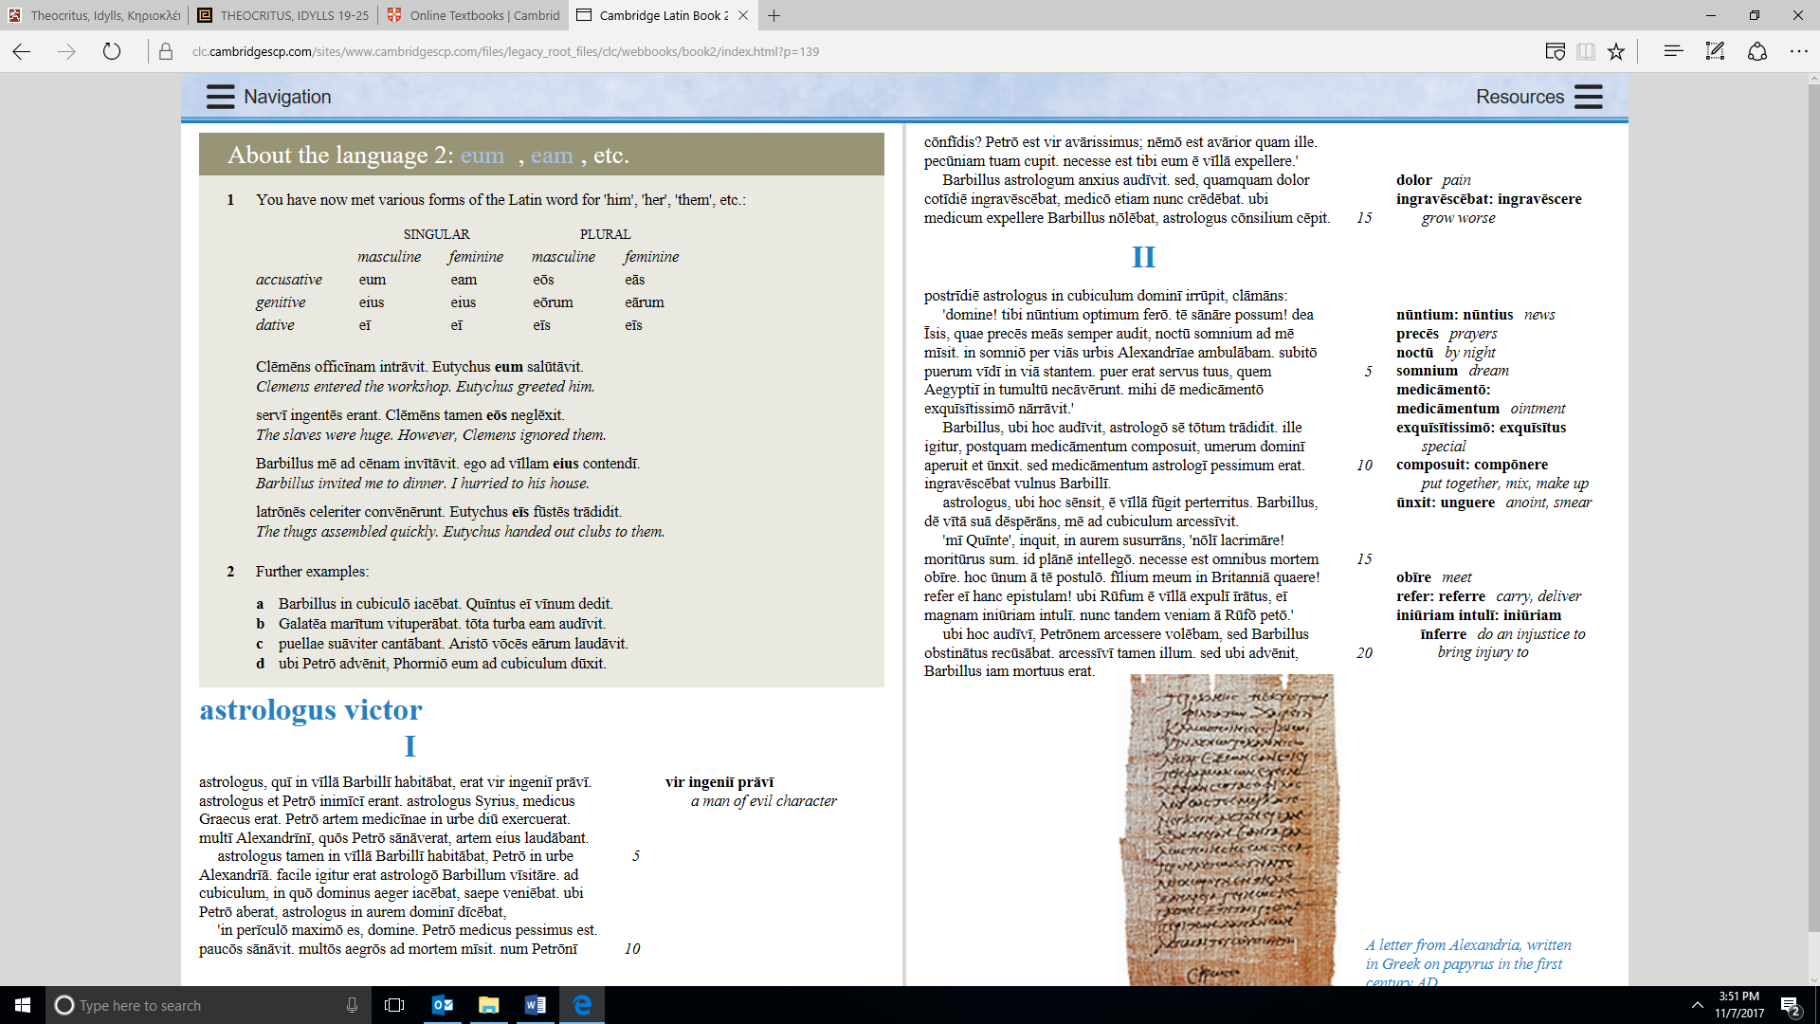
The next day the astrologer bust into his master’s bedroom, shouting:
‘Master! I bring you excellent news. I can cure you! The goddess Isis, who always hears my prayers, sent me a dream by night. In the dream I was walking through the streets of Alexandria. Suddenly I saw a boy standing in the street. The boy was your slave, whom the Egyptians killed in the riot. He told me about a special ointment.’
When Barbillus heard this, he entrusted himself totally to the astrologer. He, therefore, after mixing the ointment, opened up his master’s shoulder and anointed it. But the astrologer’s medicine was very bad. Barbillus’ wound grew worse.
When the astrologer realised this he fled from the house, terrified. Despairing for his life, Barbillus called me to his bedroom.
‘My dear Quintus,’ he said, whispering into my ear, ‘don’t cry! I am about to die. I understand that clearly. It is necessary for all men to meet their death. I ask this one thing of you. Seek my son in Britain! Deliver this letter to him! When I angrily drove Rufus out of my house, I did him a great injustice. Now at last I seek mercy from Rufus.’
When I heard this, I wanted to summon Petro, but Barbillus stubbornly refused. I summoned him nevertheless. But when he arrived, Barbillus was already dead.
Beginners’ Greek Theocritus, Idyll 19 Κηριοκλέπτης

τὸν κλέπταν πότ᾽ ῎Ερωτα κακὰ κέντασε μέλισσα
κηρίον ἐκ σίμβλων συλεύμενον, ἄκρα δὲ χειρῶν
δάκτυλα πάνθ᾽ ὑπένυξεν. ὁ δ᾽ ἄλγεε καὶ χέρ᾽ ἐφύση
καὶ τὰν γᾶν ἐπάταξε καὶ ἅλατο, τᾷ δ᾽ ᾿Αφροδίτᾳ
δεῖξεν τὰν ὀδύναν καὶ μέμφετο, ὅττί γε τυτθὸν 5
θηρίον ἐστὶ μέλισσα καὶ ἁλίκα τραύματα ποιεῖ.
χἁ μάτηρ γελάσασα: τί δ᾽; οὐκ ἴσος ἐσσὶ μελίσσαις;
ὡς τυτθὸς μὲν ἔφυς, τὰ δὲ τραύματα χἁλίκα ποιεῖς.

The honeycomb stealer.
When thievish Love was stealing honeycomb from the hives one day, a wicked bee stung him, and stung all his finger-tips. And he was in pain and blew on his hand and stamped the ground and danced, and showed his hurt to Aphrodite, and complained that so a little a beast as a bee made such great wounds. His mother laughing, said, ‘What? Aren’t you the same as bees? You are little, but you make such great wounds.
Pre GCSE Latin Virgil, Aeneid 4, lines 340 – 361
mē sī fāta meīs paterentur dūcere vītam 340
auspiciīs et sponte meā compōnere cūrās,
urbem Troiānam prīmum dulcīsque meōrum
rēliquiās colerem, Priamī tēcta alta manērent,
et recidīva manū posuissem Pergama victīs.
sed nunc Ītaliam magnam Grӯnēus Apollō, 345
Ītaliam Lyciae iussēre capessere sortēs;
hīc amor, haec patria est. sī tē Karthāginis arcēs
Phoenissam Libycaeque aspectus dētinet urbis,
quae tandem Ausoniā Teucrōs cōnsīdere terrā
invidia est? et nōs fās extera quaerere rēgna. 350
mē patris Anchīsae, quotiēns ūmentibus umbrīs
nox operit terrās, quotiēns astra ignea surgunt,
admonet in somnīs et turbida terret imāgō;
mē puer Ascanius capitisque iniuria cārī,
quem rēgnō Hesperiae fraudō et fātālibus arvīs. 355
nunc etiam interpres dīvum Iove missus ab ipsō
(testor utrumque caput) celerīs mandāta per aurās
dētulit: ipse deum manifestō in lūmine vīdī
intrantem mūrōs vōcemque hīs auribus hausī.
dēsine mēque tuīs incendere tēque querēlīs; 360
Ītaliam nōn sponte sequor.'

Had destiny permitted me to shape my life after my own pleasure and order my sorrows at my own will, my first care would be the city of Troy and the sweet relics of my king. Priam’s high house would still abide and my own hand would have set up a revived Pergamus for the vanquished. But now of great Italy has Grynean Apollo bidden me lay hold, of Italy the Lycian oracles. There is my love, there my country! If the towers of Carthage and the sight of Libyan city charm you, a Phoenician, why, pray, grudge the Trojans their settling on Ausonian land? We, too, have the right to seek a foreign realm. Each time the night with dewy shades veils the earth, each time the starry fires arise, in my dreams my father Anchises’ troubled ghost brings me warning and terror; the thought of young Ascanius comes to me and the wrong done to one so dear, whom I am cheating of a Hesperian kingdom and predestined lands. Now, too, the messenger of the gods sent from Jove himself – I sear by both our lives – has borne his command down through the swift breezes; my own eyes saw the god in the clear light of day come within our walls and these ears drank in his words. Cease to inflame yourself and me with your complaints. It is not by my wish that I make for Italy . . . “
Greek Dialogue Antigone 561-581
Κρέων τὼ παῖδε φημὶ τώδε τὴν μὲν ἀρτίως
ἄνουν πεφάνθαι, τὴν δ᾽ ἀφ᾽ οὗ τὰ πρῶτ᾽ ἔφυ.
Ἰσμήνη οὐ γάρ ποτ᾽, ὦναξ, οὐδ᾽ ὃς ἂν βλάστῃ μένει
νοῦς τοῖς κακῶς πράσσουσιν, ἀλλ᾽ ἐξίσταται.
Κρέων σοὶ γοῦν, ὅθ᾽ εἵλου σὺν κακοῖς πράσσειν κακά. 565
Ἰσμήνη τί γὰρ μόνῃ μοι τῆσδ᾽ ἄτερ βιώσιμον;
Κρέων ἀλλ᾽ ἥδε μέντοι - μὴ λέγ᾽: οὐ γὰρ ἔστ᾽ ἔτι.
Ἰσμήνη ἀλλὰ κτενεῖς νυμφεῖα τοῦ σαυτοῦ τέκνου;
Κρέων ἀρώσιμοι γὰρ χἀτέρων εἰσὶν γύαι.
Ἰσμήνη οὐχ ὥς γ᾽ ἐκείνῳ τῇδέ τ᾽ ἦν ἡρμοσμένα. 570
Κρέων κακὰς ἐγὼ γυναῖκας υἱέσι στυγῶ.
Ἰσμήνη ὦ φίλταθ᾽ Αἷμον, ὥς σ᾽ ἀτιμάζει πατήρ.
Κρέων ἄγαν γε λυπεῖς καὶ σὺ καὶ τὸ σὸν λέχος.
Ἰσμήνη ἦ γὰρ στερήσεις τῆσδε τὸν σαυτοῦ γόνον;
Κρέων Ἅιδης ὁ παύσων τούσδε τοὺς γάμους ἔφυ. 575
Ἰσμήνη δεδογμέν᾽, ὡς ἔοικε, τήνδε κατθανεῖν.
Κρέων καὶ σοί γε κἀμοί. μὴ τριβὰς ἔτ᾽, ἀλλά νιν
κομίζετ᾽ εἴσω, δμῶες: ἐκ δὲ τοῦδε χρὴ
γυναῖκας εἶναι τάσδε μηδ᾽ ἀνειμένας.
φεύγουσι γάρ τοι χοἰ θρασεῖς, ὅταν πέλας 580
ἤδη τὸν Ἅιδην εἰσορῶσι τοῦ βίου.
Creon One of these maidens, I declare, has just revealed her foolishness; the other has displayed it from the moment of her birth.
Ismene Yes, Creon. Whatever amount of reason nature may have given them does not remain with those in dire straits, but goes astray.
Creon [565] Yours did, I know, when you chose dire actions with dire allies.
Ismene What life would there be for me alone, without her presence?
Creon Do not speak of her “presence”. She lives no longer.
Ismene What? You will kill your own son's bride?
Creon Why not? There are other fields for him to plough.
Ismene [570] But not fitted to him as she was.
Creon I abhor an evil wife for my son.
Ismene Haemon, dearest! How your father wrongs you!
Creon Enough! Enough of you and of your marriage!
Ismene Will you really cheat your son of this girl?
Creon [575] Death it is who will end these bridals for me.
Ismene Then it seems that it is resolved that she will die.
Creon Resolved, yes, for you and by me.To the two Attendants. No more delay! Servants, take them inside! Hereafter they must be women, and not left at large. [580] For it is known that even the brave seek to flee, when they see Death now closing on their life.Exeunt Attendants, guarding Antigone and Ismene. Creon remains.

Open Latin Ovid Amores 1.1 lines 1 - 20

Arma gravī numerō violentaque bella parābam
ēdere, māteriā conveniente modīs.
pār erat īnferior versus: rīsisse Cupīdō
dīcitur atque ūnum surripuisse pedem.
'Quis tibi, saeve puer, dedit hoc in carmina iuris? 5
Pīeridum vātēs, nōn tua turba sumus.
quid, si praeripiat flāvae Venus arma Minervae,
ventilet accēnsās flāva Minerva facēs?
quis probet in silvīs Cererem rēgnāre iugōsīs,
lēge pharetrātae Virginis arva colī? 10
crīnibus īnsignem quis acūtā cuspide Phoebum
īnstruat, Āoniam Marte movente lyram?
sunt tibi magna, puer, nimiumque potentia rēgna;
cūr opus adfectās, ambitiōse, novum?
an, quod ubīque, tuum est? tua sunt Helicōnia tempē? 15
vix etiam Phoebo iam lyra tūta sua est?
cum bene surrēxit versū nova pāgina prīmō,
attenuat nervōs proximus ille meōs;
nec mihi māteria est numerīs leviōribus apta,
aut puer aut longās compta puella comās.' 20

Just now, I was preparing to start with heavy fighting
and violent war, with a measure to fit the matter.
Good enough for lesser verse – laughed Cupid
so they say, and stole a foot away.
‘Cruel boy, who gave you power over this song?
Poets are the Muses’, we’re not in your crowd.
What if Venus snatched golden Minerva’s weapons,
while golden Minerva fanned the flaming fires?
Who’d approve of Ceres ruling the wooded hills,
with the Virgin’s quiver to cultivate the fields?
Who’d grant long-haired Phoebus a sharp spear,
while Mars played the Aonian lyre?
You’ve a mighty kingdom, boy, and too much power,
ambitious one, why aspire to fresh works?
Or is everything yours? Are Helicon’s metres yours?
Is even Phoebus’s lyre now barely his at all?
I’ve risen to it well, in the first line, on a clean page,
the next one’s weakened my strength:
and I’ve no theme fitting for lighter verses,
no boy or elegant long-haired girl.’
Greek Chorus Antigone 781-805

Ἔρως ἀνίκατε μάχαν, Ἔρως, ὃς ἐν κτήμασι πίπτεις,
ὃς ἐν μαλακαῖς παρειαῖς νεάνιδος ἐννυχεύεις,
φοιτᾷς δ᾽ ὑπερπόντιος ἔν τ᾽ ἀγρονόμοις αὐλαῖς: 785
καί σ᾽ οὔτ᾽ ἀθανάτων φύξιμος οὐδεὶς
οὔθ᾽ ἁμερίων σέ γ᾽ ἀνθρώπων. ὁ δ᾽ ἔχων μέμηνεν. 790
σὺ καὶ δικαίων ἀδίκους φρένας παρασπᾷς ἐπὶ λώβᾳ,
σὺ καὶ τόδε νεῖκος ἀνδρῶν ξύναιμον ἔχεις ταράξας:
νικᾷ δ᾽ ἐναργὴς βλεφάρων ἵμερος εὐλέκτρου 795
νύμφας, τῶν μεγάλων πάρεδρος ἐν ἀρχαῖς
θεσμῶν. ἄμαχος γὰρ ἐμπαίζει θεὸς, Ἀφροδίτα. 800
νῦν δ᾽ ἤδη 'γὼ καὐτὸς θεσμῶν
ἔξω φέρομαι τάδ᾽ ὁρῶν ἴσχειν δ᾽
οὐκέτι πηγὰς δύναμαι δάκρυ
τὸν παγκοίτην ὅθ᾽ ὁρῶ θάλαμον
τήνδ᾽ Ἀντιγόνην ἀνύτουσαν. 805
Chorus
[781] Love, the unconquered in battle, Love, you who descend upon riches, and watch the night through on a girl's soft cheek, [785] you roam over the sea and among the homes of men in the wilds. Neither can any immortal escape you, [790] nor any man whose life lasts for a day. He who has known you is driven to madness. [791] You seize the minds of just men and drag them to injustice, to their ruin. You it is who have incited this conflict of men whose flesh and blood are one. [795] But victory belongs to radiant Desire swelling from the eyes of the sweet-bedded bride. Desire sits enthroned in power beside the mighty laws. [800] For in all this divine Aphrodite plays her irresistible game.(Enter Antigone under guard from the palace. ) [801] But now, witnessing this, I too am carried beyond the bounds of loyalty. The power fails me to keep back my streaming tears any longer, when I see Antigone making her way to the chamber where all are laid to rest, [805] now her bridal chamber.
Antigone Chorus 781- 805

U – U – – U U – U – U – – U U – –
U – U U – U – – U – U U – U – –
– – U – – U U – – U U – – –
– – – U U – – U U – –
– – U U – U – – – U U – U – X

U – U – – U U – U – U – – U U – –
U – U U – U – – U – U U – U – –
– – U – – U U – – U U – – –
– – – U U – U U U U – –
– – U U – U – – – U U – U – –

– – – – – – – –
– – U U – U U – – –
– U U – – U U – U U
– – – – U U – U U X
– – U U – U U – X

